Name: ________________________________ Date: ___________________________________

Class: _________________________________ Teacher: ___________________________________

# Math Mini Quiz 1

This Mini Quiz, we’re going to explore the math concepts that you’ve learned so far in this unit. This assignment should take you about **15 minutes**.

### Part 1 Freediving

Free diving is a sport where divers go under the water without the aid of an oxygen tank, like would be the case with scuba diving. To do this, freedivers have to hold their breaths for long periods of time with some of the longest free dives ever lasting over four minutes! Below is a list of numbers representing the highest **number of minutes** dived by the top freedivers.

3.6, 3.0, 3.1, 3.5, 4.5, 2.9, 2.8, 2.9, 2.7

1) Find the **average** of these top freediving times.

*Answer: 3.22*

*3.6 + 3.0 + 3.1 + 3.5 + 4.5 + 2.9 + 2.8 + 2.9 + 2.7 = 29*

*25.35 / 9 = 3.22*

2) Find the **median** of these top freediving times.

*Answer: 3.0*

*First put them in order: 2.7, 2.8, 2.9, 2.9, 3.0, 3.1, 3.5, 3.6, 4.5*

*Find the middle: ~~2.7~~, ~~2.8~~, ~~2.9~~, ~~2.9~~, 3.0, ~~3.1~~, ~~3.5~~, ~~3.6~~, ~~4.5~~*

3) Which of these two would you prefer to use *to describe the center* of this data? Why?

*The median in this case will best describe the center. This is because we have at least one outlier in the data, the point of 4.5 minutes. This high value will throw off the mean, but the median will be relatively unaffected.*

*(yes, there’s a back, don’t forget it)*

### Part 2 Graph Analysis

Below are the histograms of the distance thrown by two different javelin throwers.

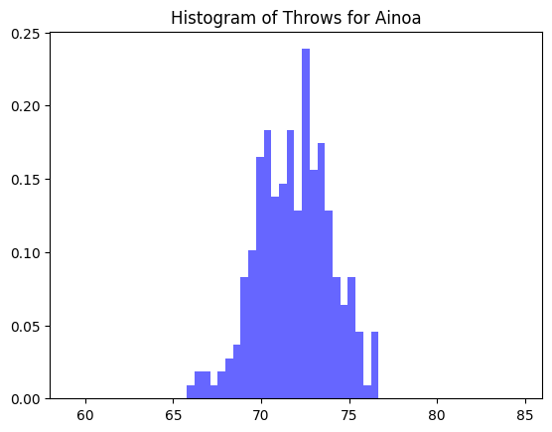 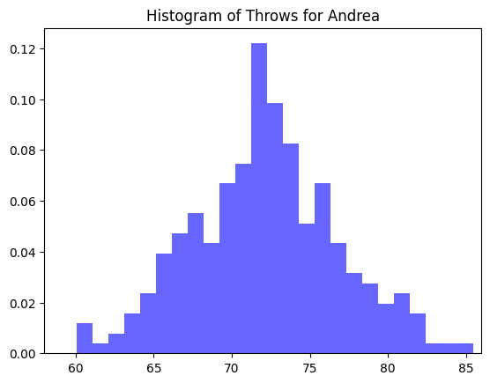

4) Which of these two has the greater standard deviation? What does that tell you about the way that person throws?

*Andrea’s throws have a higher standard deviation. This means she has a higher variety in the distances she throws. That is to say, while it’s possible for Andrea to throw her max higher than Ainoa, it’s also possible for Andrea to throw lower than Ainoa’s min. Ainoa throws more consistently within a smaller range.*

Below is a box and whisker plot of the 100m times for a highschool track team.



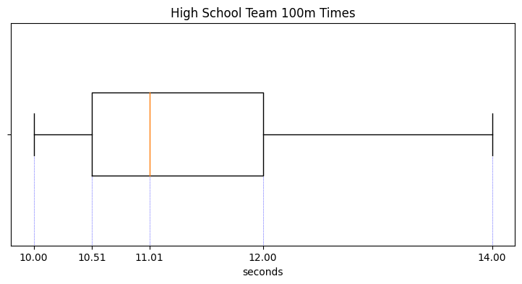

5) Can we find the mean, median, or both from this plot? How do you know? What is it/what are they?

*We can find the median, but not the mean. This is because a box and whisker plot shows us the quartiles, the middle of which would be the median not the mean. The median is 11.01 seconds.*

6) Name two ranges in which 75% of the data lies

*10.00 - 12.00, 10.51 - 14.00 ---- These are found by taking minimum up to the third quartile boundary, and the first quartile boundary up to the maximum*

*The end, good job :)*